Exercise 5: Hugging Face & Collab
Spaces demo
AI Project: DeepSite – AI Web Development Tool
Hugging Face Space: victor/deepsite
I tried the DeepSite Hugging Face Space, which is an AI web-development tool. It allows users to describe a website they want to create using natural language, and the AI generates the website/code based on the prompt. The project is described as a tool for building websites with AI without requiring coding
Prompt: "Write a Python program that checks whether a number is even or odd."
The Space generated a Python program that checks whether the given number is divisible by 2.

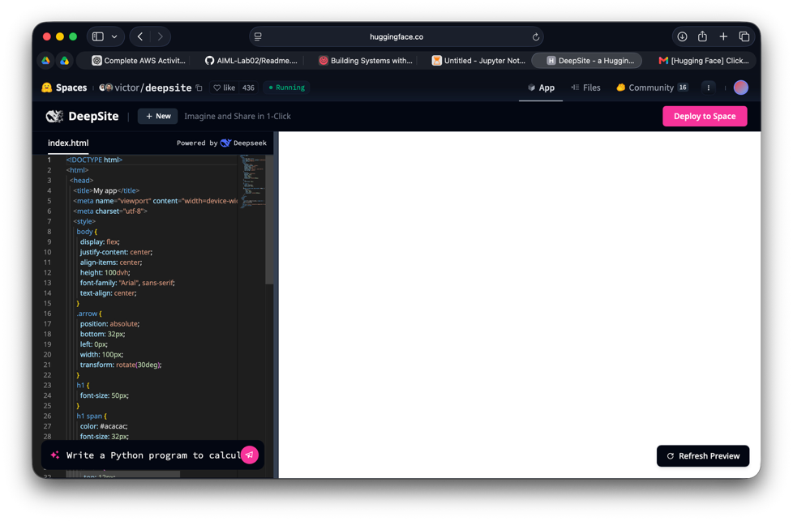
Model Details
There is one important thing to correct from your friend's PDF: DeepSite is a Hugging Face Space, not the actual model you should list under the "Models" section. Your friend's submission separately lists a model for this part.

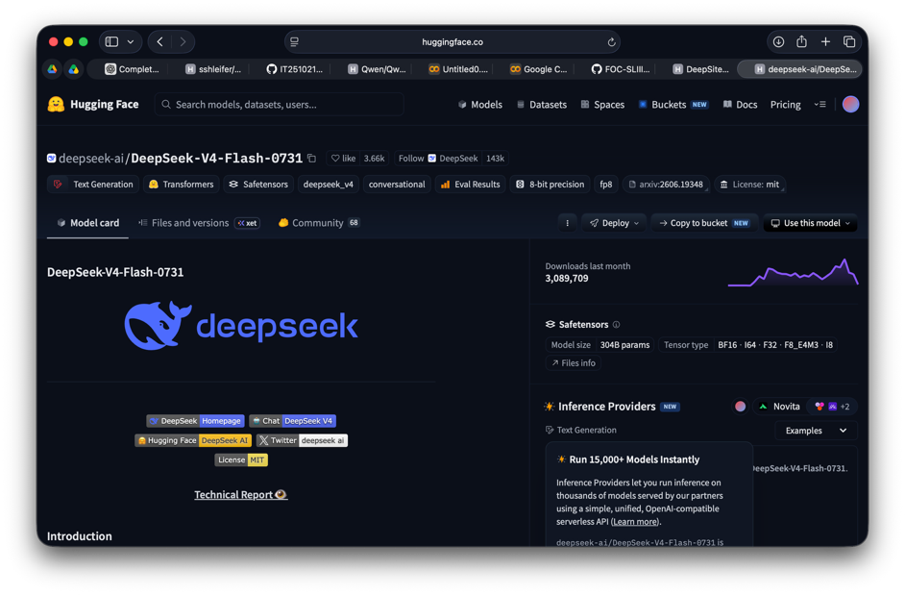
Colab: Text summarization
Note: pipeline("summarization") errored in this Colab environment (KeyError, task not registered). Worked around it using AutoModelForSeq2SeqLM directly.
Default model (distilbart-cnn-12-6): "Hugging Face is a pioneering open-source AI platform that empowers developers, researchers"
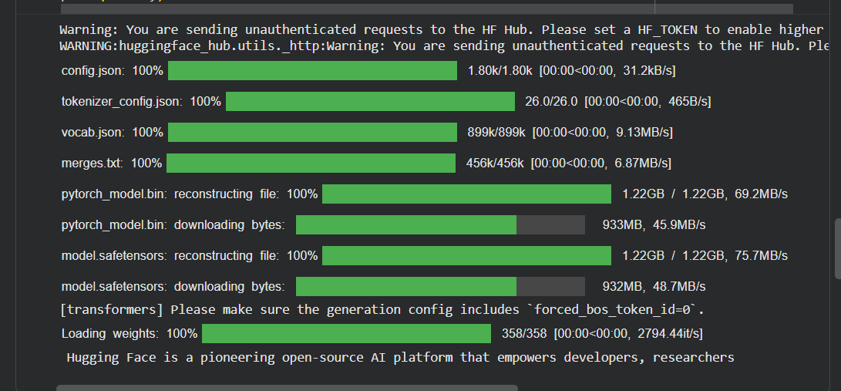
kobart-summary-v3 (Korean model, on English text): "Hugging Face is a pioneering op" - essentially a truncated echo, not a real summary, since the model isn't trained for English.
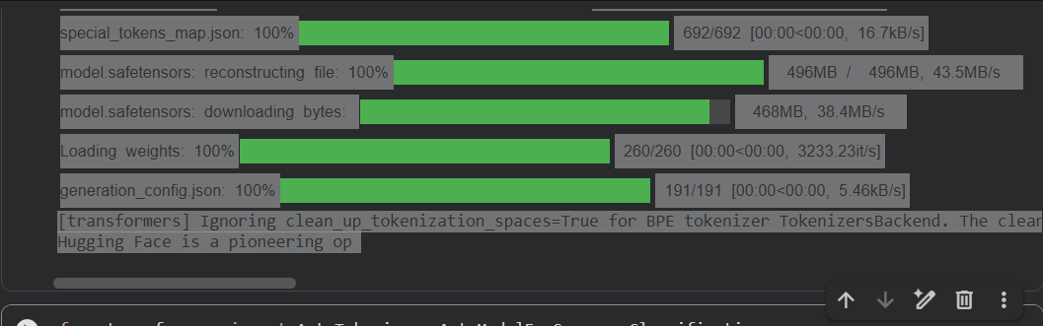
Own choice model: English -> French Translation
Model: Helsinki-NLP/opus-mt-en-fr (distinct from the sentiment model used for the model-details lookup above).
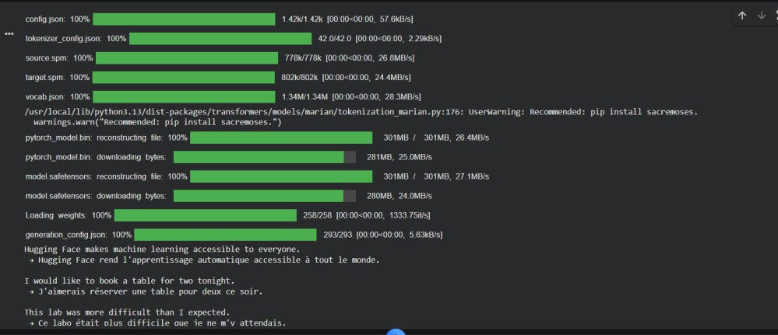

All three test sentences were translated into grammatically correct, natural French, confirming the model performs well within its trained language pair.

